Project 14

Frederick Kelemen

2715308

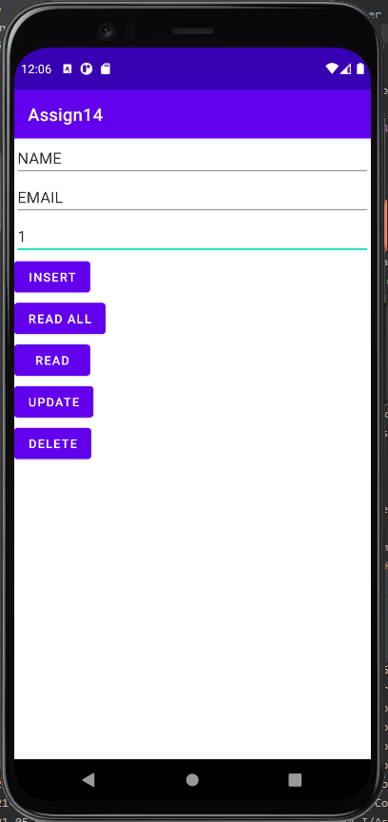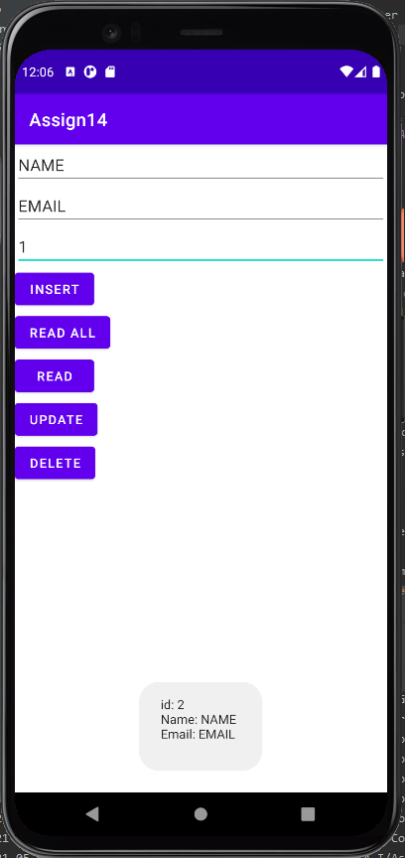Project 14 makes use of a database to implement persistence, there are 5 buttons and three edittexts, the insert button uses the name and email edittexts to put a contact at the end of the database, the read and delete buttons use the row id edittext to read or delete the desired row, the read all button uses none of the edittexts and simply lists all contacts, the update button uses all edittexts to change the email and name at the desired row. Note, upon deleting a row it's id is no longer usable neither update nor insert will change the contents of a deleted row id.